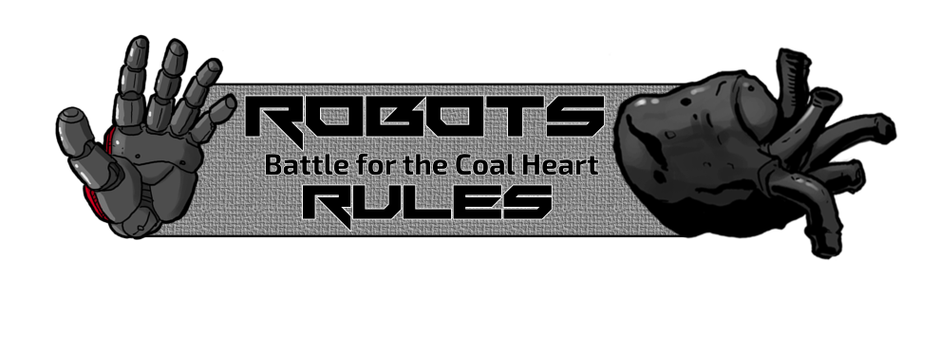

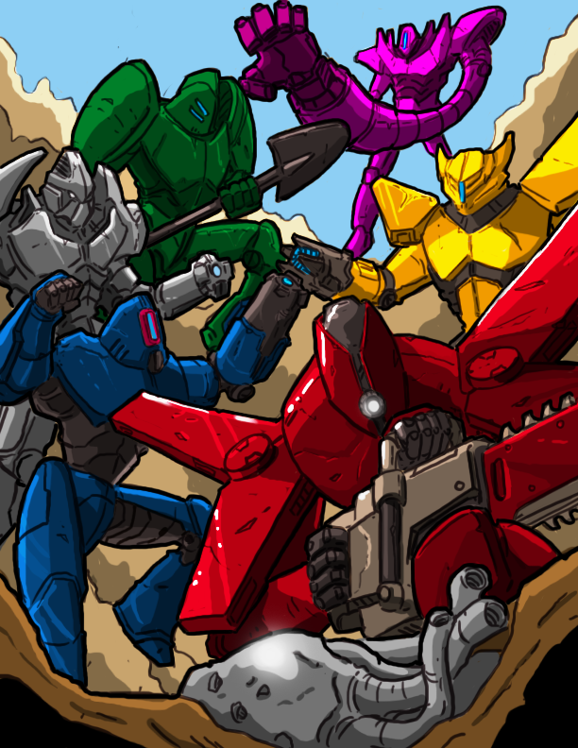

**Introduction:**

In the midst of an energy crisis that would end the robot world, the robot miners found a unique artifact: the Coal Heart of Unlimited Power. Any robot that possesses it for 24 hours becomes an indestructible, eternal source of energy for the world to idolize. Soon, robots from all over the world sought out the Coal Heart. It became a battle to the death.   
You are one of the greatest robot fighters in the world battling with the remaining contenders to capture the Coal Heart and become all-powerful!

**Components:**

32 Gear Cards  
1 Coal Heart Hex   
1 Quarry Card  
1 First Player Card

60 Resource Cubes

6 Playmats

66 Robot Parts

12 Tracker Tokens

7 Action Hexes

1 Resource Bag (“Supply”)

(15 each of black, green, blue, and gold)

**Goal:**

Win by breaking every other robot or building all 11 parts of your robot.

**Table of Contents:**

Setup P. 3

Action Hexes P. 5

Fighting P. 7

Gear P. 8

Broken P. 10

Adv. – Drafting P. 11

Adv. – Demo P.13

Body Diagram P. 14

Glossary P. 15

General FAQ P. 17

Robot FAQ P. 18

Gear FAQ P. 19

**Setup:**

1. Each player chooses a robot and takes the playmat and 11 hexes that correspond to their robot’s color, and 2 clear tracker tokens. Then from the Supply take the 2 starting resources labeled on the playmat.
2. Each player starts with no parts built, 0 attack, and 20 HP (Health Points). Place the tracker tokens on 20 HP and 0 attack.
3. Lay out the 6 Action Hexes in the middle of the table within reach of all players.
4. Randomly place resources equal to the number of players +2 on the Quarry card. Keep the remaining resources in the Supply.
5. Shuffle the Gear cards and lay out cards (face up) equal to the number of players +2. The rest of the Gear deck is placed face down next to this row. When players use Gear cards, put them into a separate discard pile next to the Gear deck. If the Gear deck runs out, shuffle the discard pile into a new deck.
6. Decide the starting player randomly. This person gets the First Player Card.

**Six Player Game Special Rules:**

Use the 6 Player Only Scavenge Action Hex in addition to the other 6 Action Hexes for a total of 7 Hexes.

**Example Layout for 4 Players:**

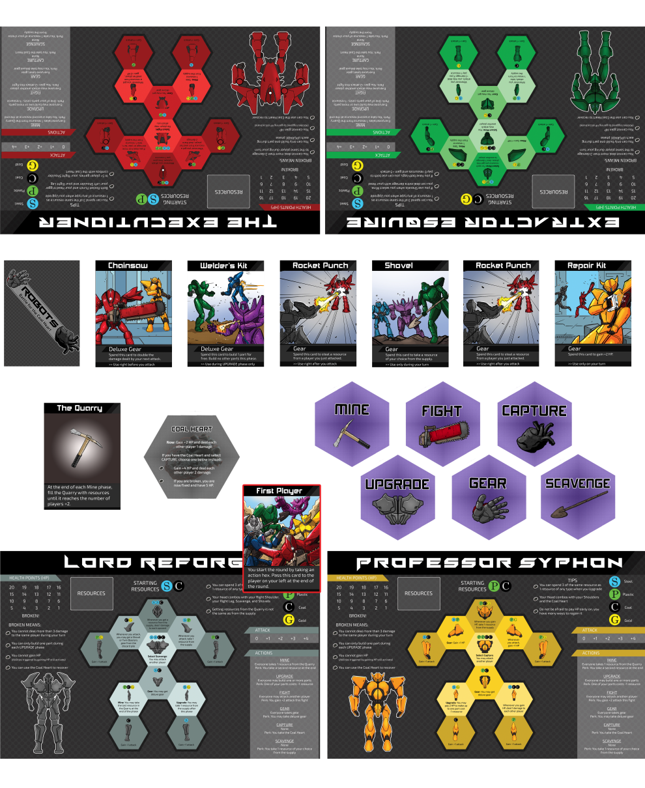

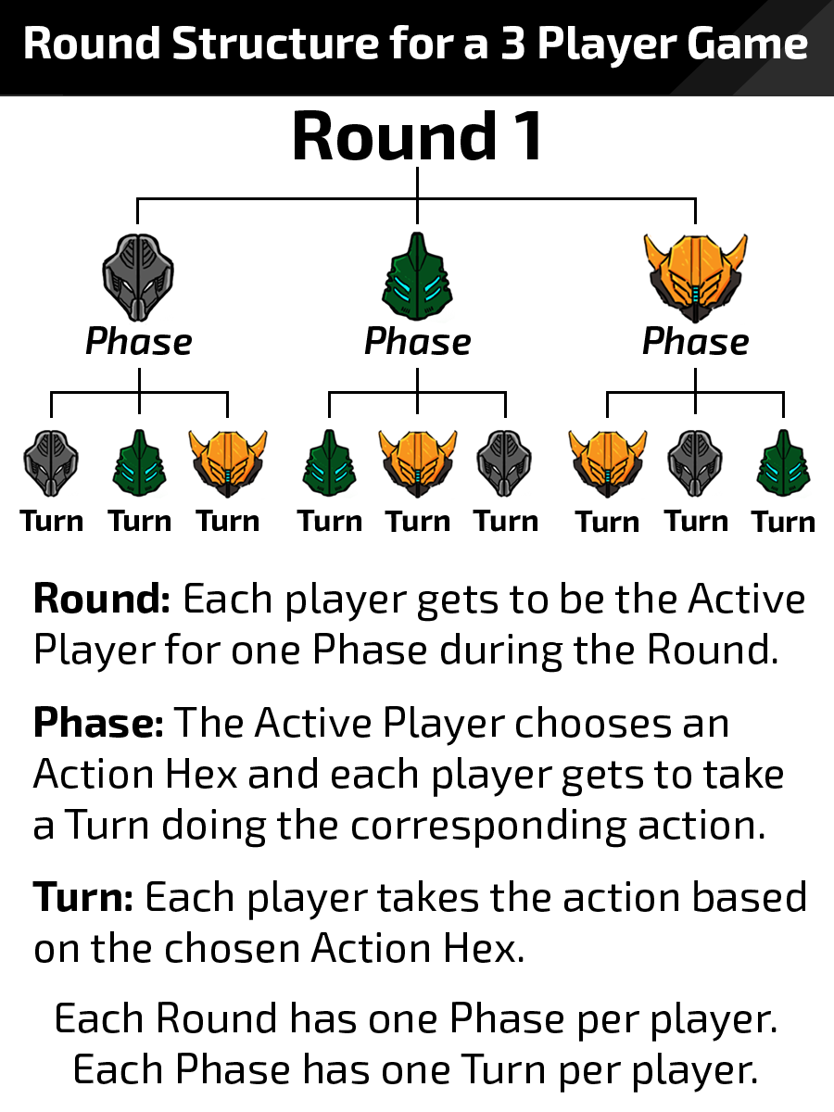

For example, if Lord Reforge (grey) is the Active Player and selects the Mine Action Hex by flipping it face down, Lord Reforge will take a resource from the Quarry (that is Lord Reforge’s Turn). Then, Extractor Esquire (green) will take a resource from the Quarry (that is Extractor Esquire’s Turn). Finally, Professor Syphon (yellow) will take a resource from the Quarry (that is Professor Syphon’s Turn). After all players have taken a resource from the Quarry, Lord Reforge takes a second resource from the Quarry for their perk for choosing the Mine Action Hex. The Mine Phase is over and Extractor Esquire becomes the new Active Player, starting the 2nd Phase of the Round 1. Extractor Esquire then selects an Action Hex, the other players take their turns, and then Professor Syphon begins their Phase.

After Professor Syphon’s Phase is over, the Round ends. Flip all used Action Hexes face up for the next round and the First Player Card passes to Extractor Esquire, who begins the next round.

**Action Hexes:**

Each Action Hex has an action that every player performs (except Capture and Scavenge) and a perk that only benefits the Active Player. When you select an Action Hex, turn it face down.

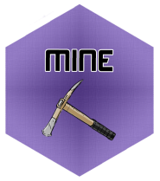Mine – Starting with the Active Player, each player takes one resource from the quarry.

Perk – The Active Player takes a second resource from the Quarry after all other players have taken one.

The Active Player will get at least two resources and every other player will get at least one resource. During this phase, some robots have parts that give them additional resources. These resources come from the Supply at random, not the Quarry (except Lord Reforge’s Left Leg). At the end of this Phase, the Quarry keeps remaining resources. Fill it from the Supply until it has resources equal to the number of players +2 .

Upgrade – Starting with the Active Player, each player may build any number of parts.

Perk – One of the parts the Active Player builds costs -1 resource of any type.

Players build parts by paying the resources listed on the part they want to build. For Example: if a part costs C:\Users\Duncan\Documents\Board Games\Robot roles\Rules\Figures\PNG\Resources.png then they must pay 1 plastic and 2 steel resources. If you reduce the cost of a part, you choose which resource not to pay. If the above part costs -1 resource, you could pay 2 steel or 1 steel and 1 plastic to build it.

*Optional Rule:* Some players may prefer that everyone Upgrade at the same time to improve the efficiency of gameplay .

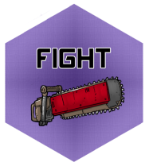Fight– Starting with the Active Player, each player may attack one other player. The player deals damage equal to their current attack value (tracked on the playmat).  
Perk – The Active Player gains +2 attack during this phase only.

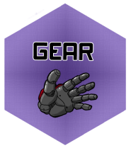All robots start with 0 attack. The hands and feet of the robots increase the attack value of the robot. A robot deals damage equal to its attack value (the sum of all its parts that increase attack) when it attacks another robot. Various abilities and gear cards increase the attack/damage a robot deals in combat.

Gear – Starting with the Active Player, each player takes a Gear card.

Perk – The Active Player may take Deluxe Gear.

See more about Gear below .



Capture – Only the Active Player performs an action this Phase.

Perk – The Active Player takes the Coal Heart.

When a player takes the Coal Heart, they activate the NOW ability and every other player does nothing on their Turn. If they select Capture when they already have the Coal Heart, they can choose to use one of the two other abilities on the card. Players may use Gear cards that are usable only on their Turn.

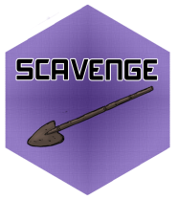Scavenge – Only the Active Player performs an action this Phase.  
Perk – You take one resource of your choice from the Supply (not the Quarry).

When a player picks Scavenge, they take a resource of their choice from the Supply and every other player does nothing on their Turn. Players may use Gear cards that are usable only on their Turn during the Scavenge Phase.

**Parts:**

When you build a part, it has a cost and an ability. The cost is at the top of the hex and shows which resources are required to build it – see “Upgrade” section for more information.

The ability at the bottom tells you when it activates and what the ability does. For example, “**Mine**: Take 1 resource from the Supply” means that the owner of this part will take a random resource from the Supply before selecting a resource from the Quarry on their Turn whenever any player selects Mine. “**Select Mine**: You may attack another player” means the owner of this part must be the player to select Mine in order to use the ability.

**Fighting**:

When you attack another player, follow these steps:

1. Choose which player you are going to attack.
2. Use any number Twin Blasters and/or Chainsaws (gear cards noted for use “right before you attack”).
3. Activate any “Whenever you attack” abilities. If you have more than one ability, you may activate them in any order.
4. Defender may use Force Field.
5. Damage is dealt.
6. Attacker may use Rocket Punch.

When dealing damage, always apply the Chainsaws last.

For example, if you start with an attack value of 2 (you have built 2 hands and/or feet) and then you:

* Spend a Twin Blasters to gain +2 damage
* Spend a Chainsaw to double your damage
* Activate a part with a “whenever you attack” ability that gives you +3 damage

You deal a total of 14 damage in that Turn.

**Gear:**

There are 2 types of Gear: Regular and Deluxe. Regular is available to anyone during the Gear phase. The Deluxe Gear is only available to the Active Player and any robot with their Core built.

All Gear cards give you access to a one-time-use ability. When you spend a Gear card, place it in a discard pile next to the Gear deck. Each Gear card can only be used at the time specified on the bottom of the card.

Deluxe Gear:

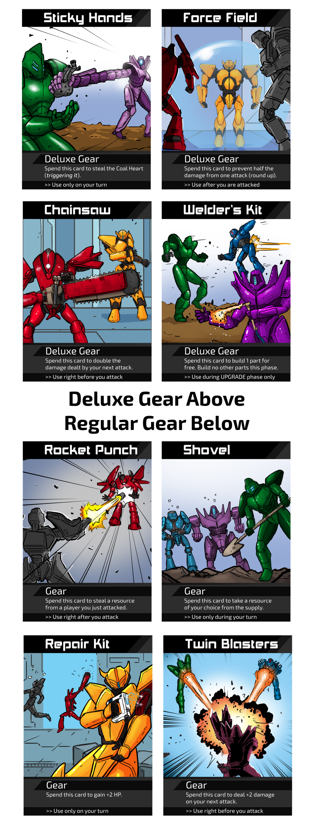



Regular Gear:

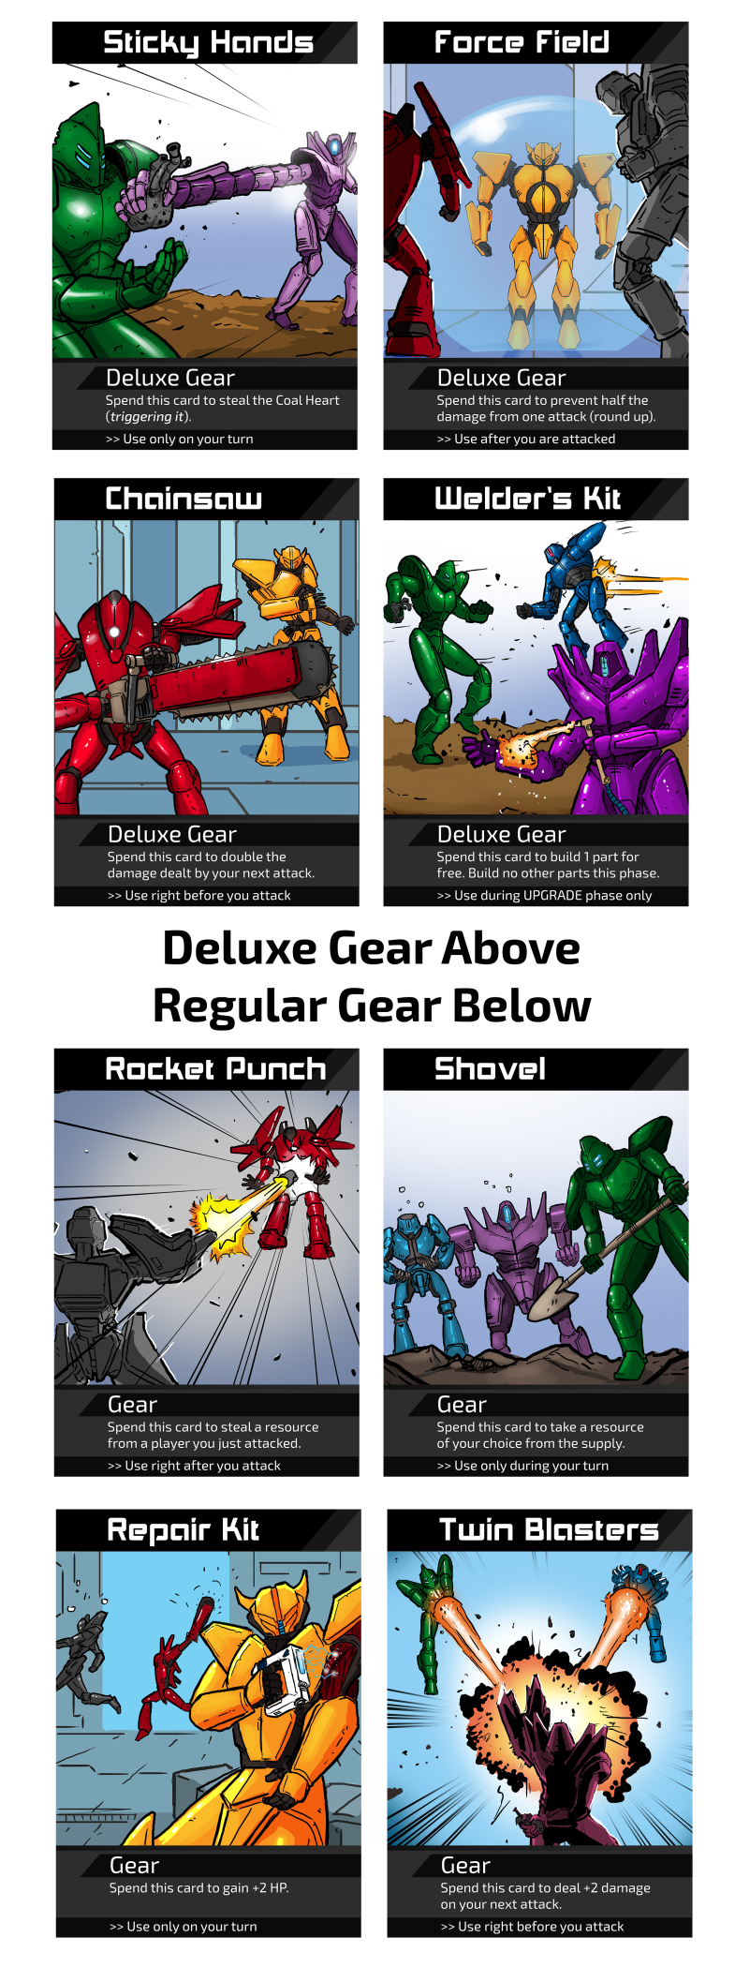

For more information about specific Gear, please see the Gear FAQ on page 19.

**Broken:**  
When you are broken, you:   
1) Cannot deal more than 3 damage to the same player on your Turn.  
2) Cannot build more than 1 part during the Upgrade phase.

3) Cannot gain HP, but abilities that trigger when you gain HP still activate.  
4) Can only recover by using the Coal Heart.

1) “You cannot deal more than 3 damage” means when you are attacking or using a part to damage a player, any instance that would have dealt higher than 3 damage is now only 3 damage. If you have already dealt 3 damage to a player, further damage you deal that player this Turn is reduced to 0. This limitation only counts damage dealt to a single opponent, so you could deal several players 3 damage each.

2) Broken robots cannot build more than one part, regardless of how many resources they have. This restriction includes using an ability or equipment to pay for a part.

3) When you are broken, you cannot gain HP. Abilities that trigger when you gain HP still happen, but you remain broken and your HP stays at 0.

4) The Coal Heart allows you to recover from being broken. If you have the Coal Heart and select CAPTURE, you recover from being broken and go to 5 HP.

You cannot pay HP when you are broken (you have no HP to pay). You can still finish your robot and win if you are broken.

**Advanced Mode – Drafting your own Robot:**

After everyone at the table has played a few times, we recommend this alternative setup as a way to increase the strategic depth of creating a robot. At the start of the game, deal each player a playmat. Place all 66 robot parts in the center of the table, regardless of which robots are in the game. Choose a starting player randomly and give that player the “First Player” card.

Starting with the First Player, each player takes a robot part of any color. After everyone has taken a part, the First Player card passes to the left and the next round of drafting begins. Each robot must ensure that they have one of each of their different body parts.

A player should end with

1 Head

1 Chest

1 Core

2 Shoulders (1 left and 1 right)

2 Legs (1 left and 1 right)

2 Arms (1 left and 1 right)

2 Feet (1 left and 1 right)

Once a player has one of a type of body part, they may not draft another body part of that type. For example, if Player 1 drafts Professor Syphon’s Right Leg, they may NOT draft Lord Reforge’s Right Leg.

After everyone has 11 parts to make a full robot, the First Player card passes a final time and the new First Player starts the game. Give each player the starting resources noted on their playmat.

Other than starting with a hodgepodge of different colored parts, the game plays the same way with the same rules.

**Advanced Mode – Demo**

If you do not have time for a full game, try this quicker version for a game that lasts around 15 – 20 minutes. Players start with 4 parts already built (described below), 15 HP, and their starting resources.

Starting Parts:

The Executioner – Head, both Feet, and Left Shoulder.

Lord Reforge – Head, both Feet, and Right Shoulder.

Extractor Esquire - Head, both Feet, and Right Shoulder.

Gizmo Guru - Head, both Feet, and Left Leg.

Professor Syphon - Head, both Feet, and Right Shoulder.

Dr. Constructor - Head, both Feet, and Left Leg.

Excluding the changes noted above, the demo follows the same rules as the original game.

**Reference Section**

**Body Diagram:**

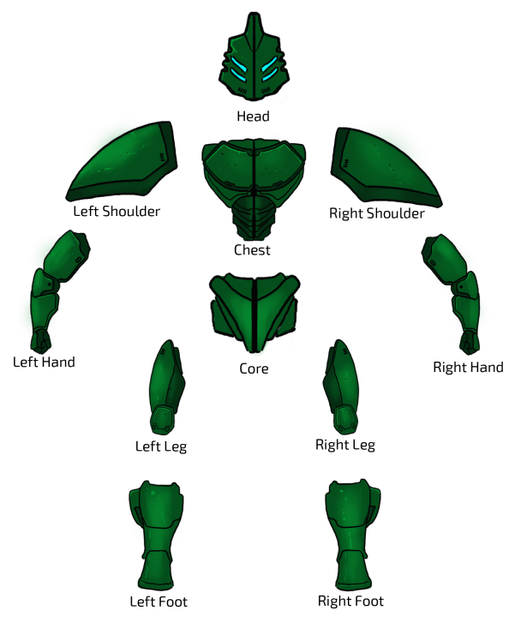

**Glossary:**

Action Hex – The Action Hexes determine what each player does on their Turn. A different Action Hex is picked in each Phase and only once in a Round.

Active Player – This player picks the Action Hex in the Phase. In a Round, each player gets to be the Active Player once.

Attack/Damage – For each hand or foot you build, your attack value increases. Whenever you attack another player, you deal damage equal to your attack value plus any bonuses from other body parts, Action bonuses, or Gear usage bonuses. (For example, parts like Extractor Esquire’s Right Leg, the bonus for selecting the Fight Action Hex, or bonuses from Gear like Twin Blasters).

Coal Heart – Players who select Capture or use the Sticky Hands Gear take the Coal Heart. A player keeps the Coal Heart until someone takes the Coal Heart from them. Abilities on the Coal Heart that are activated by selecting Capture cannot be activated by Sticky Hands.

Gear – Gear are one-time-use cards that give a variety of benefits. Acquire Gear by selecting the Gear Action Hex.

HP (Health Points) – Each player starts with 20 HP and becomes broken when they reach 0 HP. You cannot go above 20 HP or below 0 HP.

Part – Each robot has 11 parts. Players build parts when a player selects the Upgrade Action Hex. Parts cost resources based on the letter(s) at the top of the hex.

Phase – During a Phase, the Active Player gets to choose an Action Hex, which allows each player to take a Turn doing a specific action.

Quarry – The Quarry is the place where resources are stored before being taken when a player selects Mine. It should always have resources equal to the number of players +2.

Resource – These are the cubes used to pay for parts and abilities. There are 4 different types: Steel (blue), Plastic (green), Coal (black), and Gold (yellow).

Round – In a Round, each player gets to be the Active Player for 1 Phase starting with the player with the First Player Card. After each player has led a Phase, the Round ends, the First Player Card passes, and the Action Hexes are refreshed so that any of them can be picked in the new round.

Select [*Action*] – This ability only triggers when you are the player that selects the given Action Hex as the Active Player. If another player selects that Action Hex, this part does not activate.

Supply – The Supply is the bag that holds all the resources that are not in the Quarry or in a player’s possession. The Supply is not the Quarry. All resources taken from the Supply are at random unless it is from using the Shovel Gear or from selecting the Scavenge Action Hex.

Turn – Once the Active Player has selected an Action Hex, each player takes a Turn performing the corresponding action.

Number of players +2 – If there are 3 players, this number is 5.

**General FAQ**

If every robot would break at the same time, the newly broken player with the most parts already built on their robot wins.

If you attack during an Upgrade Phase, you must first deal damage before building your new part(s).

If you build a part that effects the Upgrade phase, it does **NOT** activate on the Turn you build it.

Abilities that say NOW immediately activate. You cannot save them for later.

Parts have no effect on the game until they are built.

Attacking is only when the card, hex, or ability says “attack.” Damaging another robot with your part’s abilities is not attacking them.

**Robot-Specific FAQ**

Dr. Constructor:

The Right Shoulder can trade for shoulders and legs, not feet or hands.

If you are broken, you cannot pay HP with the Left Leg.

The Head does not deal damage in the same Turn that it is built.

The Executioner:  
When determining damage dealt with the Right Shoulder, count the total damage. If you deal 4 players each 1 damage, you will get a resource. The Right Shoulder can only give you one resource per Turn.

When you get a resource from another player with the Head, that player chooses which resource to give you.

The Left Shoulder and Right Leg activate when you use your Head or Rocket Punch Gear.

The Chest only prevents people from attacking you, not from using other abilities that damage you.

Extractor Esquire:

The Head counts any resources gained that Phase, even ones from Shovel Gear, the Left Leg, or any other abilities.

If you have both legs built, you may get one resource from attacking and immediately spend it to increase your attack.

Gizmo Guru:

You can get Deluxe Gear with your Left Leg.

You can use your Left Shoulder any number of times in a single Upgrade Phase.

Lord Reforge:

The Head does not trigger when you get a resource from the Quarry.

The Right Leg does not activate the Turn you build it.

When you use your Left Shoulder to get a Twin Blasters Gear, you cannot use it on that attack. However, if you used a Twin Blasters before you attacked, you can get that Twin Blasters back.

Professor Syphon:

If you are broken, you cannot pay HP with the Left Leg.

The Head and Right Leg activate whenever you gain HP regardless of how you gained it.

**Gear FAQ**

Chainsaw – Double at the end, so it is often best to use Twin Blasters and parts that give you additional attack before using the Chainsaw to double. When your opponent has a Chainsaw, break them before they can build a one-shot combo to break you!

If you use a Chainsaw when you are broken, you still cannot deal more than 3 damage.

Force Field – The damage is cut in half (rounded up). For example, if you would have taken 5 damage, now you take 2 damage. Force Field is especially good against a Chainsaw combo.

Sticky Hands – You can use Sticky Hands to take the Coal Heart before you select an Action as the Active Player. Sticky Hands is especially useful once you are broken so that you can fix yourself. If you already have the Coal Heart and you use Sticky Hands, you activate the NOW ability.

Welder’s Kit – When you use the Welder’s Kit, you cannot build any other parts during that Upgrade Phase. You cannot build parts and then use the Welder’s Kit. You cannot use two Welder’s Kits in an Upgrade Phase.

Twin Blasters – When you use Twin Blasters, you deal 2 more damage on only the next attack. Twin Blasters does not increase the damage dealt by body parts, only attacks.

Repair Kit – You can only use this on your Turn. If someone breaks you, you cannot gain +2 HP in response. Gaining HP from the Repair Kit triggers Professor Syphon’s Head and Right Leg.

Rocket Punch – You choose the resource you are taking. This triggers The Executioner’s Left Shoulder. Use this ability after you finish your attack.

Shovel – You choose the resource you get from the Supply. The Shovel triggers Lord Reforge’s Head. If you use Shovel during the Mine phase and Extractor Esquire selected Mine, the Shovel will increase the damage dealt Extractor Esquire’s Head.

**Credits:**

Game Design Duncan Davis and Jackclyn Ngo

Editing Jackclyn Ngo and Dale King

Illustrations Gil Geolingo

Graphic Design Courtney Niskala, Jackclyn Ngo, and Duncan Davis

Playtesters Jackclyn Ngo, Nick Bragdon, Laura Weiser, Preeta Datta, Vivek Singh, Dale King, Mike Spremulli, Dashiell Davis, Douglas Davis, Becklin Davis, Darcy Davis, Caitlyn Duggan, Evan Andrews, Allen Cardozo, Tanios BouRamia, David Mescavage, and Billy Ngo

If you have any questions of comments, please email us at sherwoodcardgames@gmail.com

**Thank you to all of our backers!**

Jon Pehrson (Deluxe)

Jeff Smith (Deluxe)

James Bond (Deluxe)

Michael Spitler (Deluxe)

Matt Slone

Rob Genadio

Stuart Patterson

Ryan Maloney

Gediminas Kazanavicius

Mike

Daniel Allan

Don Eisele

Jeffrey Wijtman

Robert T. Hartsell

Mark Walker

Alicia Morse

orabbi

Scott Dillin

Jack Gulick

Hodgy

Daniel Auxier

Tandemarcher

Lori-Ann D'Antonio

Claire Laties Davis

Griffin

Mike Brown

Doug Davis

Brett Baumgarten

Dale Robin King

Pandagm

Jay Hammer

Eugene Shenderov

Richard Boreham

Alan Gerding

**Come Support Sherwood Games on:**



sherwoodgames.com



@Sherwood Games



tinyurl.com/BGG-SherwoodGames



@SherwoodGames